**Annual Conference and Symposium**

|  |  |  |
| --- | --- | --- |
| **Annual Conference** | | |
| **Date** | **Year** | **Conference / Symposium Topic** |
| 20, Jun | 2024 | Seminar on Changes in Russia under the Russo-Ukrainian War |
| 14, Jun | 2024 | President Vladimir Putin's visit to Beijing after his re-election: Russian-Chinese historical conflicts in the Far East |
| 07, Jun | 2024 | Seminar of Kant on Perpetual Peace: A Possible Utopia (Series 2) |
| 05, Jun | 2024 | Russia’s War in Ukraine: Implications for Ethnic Relations |
| 24, May | 2024 | Seminar of Kant on Perpetual Peace: A Possible Utopia (Series 1) |
| 18, May | 2024 | Speech: I came from the war: Memoirs of the Ukrainian |
| 03, May | 2024 | Lecture on Ukraine: Overview and Lessons Learned |
| 01, May | 2024 | Lecture on Geopolitical Tug-of-War in the Balkan |
| 10, Apr | 2024 | Lessons Drawn from Czech Transition to Democracy |
| 22, Mar | 2024 | Forward to 2030: Prospects for Social and Economic Development in Russia |
| 08, Mar | 2024 | Survival of Russian Enterprises under Economic Sanctions (2014-2021) |
| 08, Dec | 2023 | Kuwait State and History |
| 29, Nov | 2023 | Lecture on Marxism in Russia: From its origins to Lenin and Stalin |
| 29, Nov | 2023 | Eastern Europe's Economic Reforms and China's Early Reforms and Openness: An Exchange of Knowledge (1978-1985) |
| 15, Nov | 2023 | Taiwan as the Global Significance of China's Border |
| 10, Nov | 2023 | International Symposium on Russia-East Asia Relations under the Russia-Ukraine War |
| 17, Oct | 2023 | Seminar of Poland's Foreign Policy |
| 21, Mar | 2023 | Economy Outlook in Russia and Ukraine |
| 24, Mar | 2023 | One year of Russia's War of Aggression against Ukraine |
| 21, Feb | 2023 | International Symposium on Multifaceted Study of Northern Culture: Cross-Strait and Cross-Korea Perspectives: Post-conference |
| 03, Feb | 2023 | Peripheral Liberalism |
| 04, Oct | 2023 | De-Sovietisation in Xinjiang |
| 06, Dec | 2022 | Symposium on Current Situation and Prospects of Russia |
| 02, Dec | 2022 | From Regional Studies to Technology Industries: Cross-Domain and International Mobility |
| 28, Nov | 2022 | Wandering between the Transcaucasus and the Caucasus |
| 21, Oct | 2022 | Symposium with Gorbachev and the World Today |
| 03, Oct | 2022 | Growth-Trade Nexus across Russia and the EU |
| 28. Mar | 2022 | Bilateral relations between Taiwan and Russia |
| 25, Mar | 2022 | Symposium on the Impact of the Russian-Ukrainian War on Both Sides and the World Situation |
| 21, Dec | 2019 | Thirty Years After Communism: Continuity and Change |
| 1, Dec | 2018 | Academic Forum on Russia and and Eurasia. |
| 19, Dec | 2017 | International Symposium on "Political and Social Developments in Russia and Eurasia" |
| 4, Nov | 2016 | International Symposium on "Conflict Management: A Russian Perspective"? |
| 8, May | 2015 | Academic Forum: Russia and? World War II |
| 18, Mar | 2014 | Crimea Referendum and the Situation of Ukraine? |
| 15, Nov | 2013 | International Conference on Russia and East Asia |
| 17, May | 2013 | Russian under Vladimir Putin |
| 12-13, Nov | 2012 | 2012 Taipei-Moscow Forum: A New Policy Perspective |
| 26, Nov | 2011 | Russia in Eastern Asia: the dialogue between Taiwanese, Japanese and Russian Scholars |
| 13-14, Nov | 2010 | International Conference on the Modernization of Russia and Eurasia: Challenges and Opportunities |
| 14, Nov | 2009 | Twenty Years After Communism: Continuity and Change |
| 8-9, Nov | 2008 | International Conference on State Governance and Democratic Practice in Russia |
| 19, May | 2007 | Challenges and Perspectives of the Democratic Development in CIS States |
| 18, Nov | 2006 | 2006 Taipei-Moscow Forum International Conference |
| 19-20, Nov | 2005 | 2005 Taipei-Moscow Forum International Conference |
| 27, Nov | 2004 | 2004 Taipei-Moscow Forum International Conference |

|  |
| --- |
|  |

|  |  |  |
| --- | --- | --- |
|  |  |  |
| Seminar on Changes in Russia under the Russo-Ukrainian War  20 June, 2024 | President Vladimir Putin's visit to Beijing after his re-election: Russian-Chinese historical conflicts in the Far East  14 June, 2024 | Russia’s War in Ukraine: Implications for Ethnic Relations in Estonia  05 June, 2024 |
|  |  |  |
| Seminar of Kant on Perpetual Peace: A Possible Utopia (1 & 2)  24 Mar, 2024 ; 07 June, 2024 | Speech of I came from the war: Memoirs of the Ukrainian  18 March, 2024 | Ukraine: Overview and Lessons Learned  03 May, 2024 |
|  |  |  |
| The Geopolitical Tug-of-War in the Balkan  May 1, 2024 | Lessons Drawn from Czech Transition to Democracy  10 April, 2024 | The Future of Russia (Society, Economy) Scenario for 2030  22 March, 2024 |
|  |  |  |
| Big Business in Putin's Russia  15 March, 2024 | Survival of Russian Enterprises under Economic Sanctions (2014-2021)  08 March, 2024 | State of Kuwait: Fact,History and Invasion  08 December, 2023 |
|  |  |  |
| The Practice of Marxism in Russia: From its Origins to the Periods of Lenin and Stalin  29 November, 2023 | The Global Significance of Taiwan as China's Boundary  15 November, 2023 | The Impact of Russo-Ukrainian Conflict on Relations between Russia and East Asian Countries  10 November, 2023 |
|  |  |  |
| Polish and Taiwanese Prespectives on Africa  17 October, 2023 | Poland’s Foreign Policy  17 October, 2023 | Soviet History - The Rise of Stalinism  03 September, 2023 |
|  |  |  |
| The Process of 'De-Sovietisation' in Xinjiang (1949-1991)  04 January, 2023 | Symposium on Current Situation and Prospects of Russia  6 December, 2022 | Wandering between the Transcaucasus and the Caucasus  28 November, 2022 |
|  |  |  |
| Symposium on Gorbachev and the World Today  21 October, 2022 | Bilateral relations between Taiwan and Russia  28 March, 2022 | Symposium on The Impact of the Russian-Ukrainian War on Both Sides and the World Situation  25 March 2022 |
|  |  |  |
| Thirty Years After Communism: Continuity and Change,  21 December, 2019 | Russia and World War II,  8 May, 2015 | Crimea referendum and the Situation of Ukraine, 18 March, 2014 |
|  |  |  |
| International Conference: Russia and East Asia, 15 November, 2013 | Russia Under Vladimir Putin,   17 May, 2013 | 2012 Taipei- Moscow Forum:  A New Policy Perspective, 12-13, Nov, 2012 |

**Master Lecture**

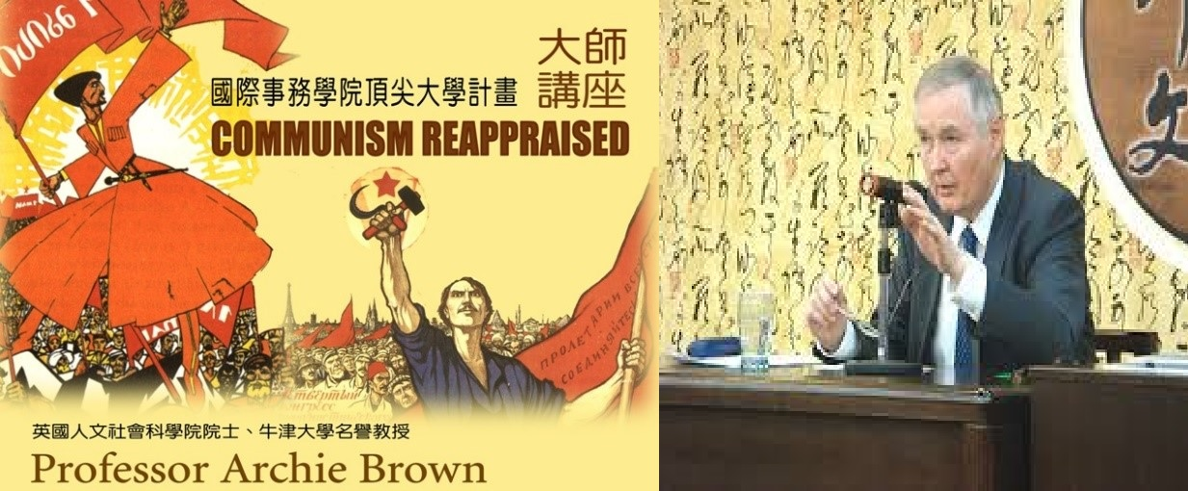

|  |  |  |  |  |
| --- | --- | --- | --- | --- |
| **Master Lecture** | | | | |
| Date | Year | Visiting Scholar | Position | Lecture Topic |
| 13-16 April | 2010 | Archie Brown | Emeritus Professor of Politics at Oxford University  Fellow of the British Academy | Communism Reappraised  •How do we explain the rise of Communism?  •Why did Communism last so long?  •Why did Communism end in Europe and mutate in Asia  •What are the lessons of the Communist experience? |